Bluetooth beacon WJ-N28
FEATURES
- Programmed standard firmware
- IP67 waterproof
- Included 2 CR2450 coin battery
- The max. 60 meters advertising distance
- Ultra-low power consumption chipset nRF51822 with ARM core
- Easy to print the logo on the center of top case;
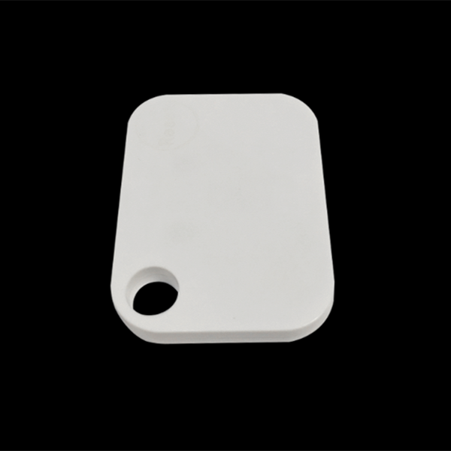
SPECIFICATION
Compatibility
- Supported iOS 7.0+ and Android 4.3+ system;
- Compatible with Apple iBeacon (Eddystone is optional);
- Compatible with all Bluetooth 4.0 (BLE) devices;
Long Battery Lifetime and Battery Level
- Up to 36 months;
- Easy to get the real-time battery level notification;
Soft-reboot
- Reboot the device via command without any tools;
Connection Mode
- Advertising mode, non-connectable;
- Configuration mode, connectable;
Configurable Parameters
- UUID, Major, Minor, Device Name, Password etc.
- Special Configuration APP;
Transmission Power Levels
- Transmission power range: -23dBm to 0dBm;
Long Range
- The max. Range 50 meters in the open space;
- The range depends on the physical environment;
Security
- Characters password (Lock/Unlock parameters);
- Broadcast the encrypted data if needed;
- AES HW encryption

ELECTRONIC PARAMETERS
Item | Value | Remarks
Firmware | BLE4.0 | V1.6
Software | iBeacon | V1.6
Battery Type | CR2450 | 3V DC, 2 pcs
Operation Voltage | 2.0-3.3V | DC
Frequency Range | 2.4GHz-2.4835GHz | Programmable
Sleeping Power | 12uW
Sleeping Current | 2uA
Modulation | Q-QPSK
Standby Current | 28μA (average) | Depends on duty cycle /broadcasting cycle
Receiving Sensitivity | -93dBm | High gain mode
Transmission Distance | 50meters | BER<0.1%, Open space
Antenna | 50ohm | On board / PCB Antenna

DEFAULT SETTING
Specification | Default Value
UUID | FDA50693-A4E2-4FB1-AFCF-C6EB07647825
Major | 10001(0-65535)
Minor | 19641(0-65535)
Transmission Power | 0dBm(-23~0dBm)
Change Password | Letter and No. (5 bytes)
Broadcasting Interval | 500ms(100-2000ms)
Serial ID | Radom(0-65535)
Connection Mode | Connectable and not connectable
Soft Reboot Pass Word | AA14061112

SPECIFICATION
Item | Value
Chipset | Nrf51822
Size | 55*40*6 mm
Weight | 21.8g
Material of Shell | ABS
Color | White
Protocol | Bluetooth low energy 4.0 ibeacon

